Notepad -

OfficeSupplies.csv

Person who made the most sales in a single region.

Total 3 regions = 3 Bonuses

-----------------

Open Tableau

1 . Import Data Source

- Connect - And import excel file --> Sheet 1

Dimensions - Categorical data

Measures- Numerical data

Add - region and unit fields and explore a bit

-----------------

Creating a calculated field

Question - What each representative sold -

Answer - Use the rep and item fields to plot the graph for overall item

Use the rep, item and units field to plot the graph for each individual item

Break it down by Region - Add the region field in columns with rep

Add the the units in rows

But this is for number of items sold

We want to see the amount in dollars of items sold by each rep

- So multiply number of units sold by unit price

eg - 42 units x 4990 each

Right click on measures --> Create calculated field --> Total Sales --> Units * Unit Price

--> 2 Columns -- Rep, Region --> 1 row --> Total Sales

--> Click on column to order by descending order

And the answer is Matthew Susan James for Central East West repectively

-----------------------

Adding Colors

is automatic but if not - Press ctrl and drag Rep column over the color section

Better way - Use the sum of Total Sales Column instead or

The best is to use Region Column Instead

-----------------------

Adding labels and formatting

To add a label - Drag the sum of Total sales column and put it on the labels section

Right click on sum(Total Sales) --> Format --> Pane --> Change numbers to Currency

Format axis -

Right click on axis --> Format --> Axis --> Font = 12

-----------------------

Part 2 -

Data mining in Tableau

- Duplicate Row Number column

Rename --> Number of Records

Click --> Change Measure(sum) to Measure(count)

Add it to the row

1 - Connect Churn modelling excel file --> add data source

2 - Turn the Geography text field to Location field

- Right click --> Duplicate column --> Right Click --> Geographic role --> country/Region

- latitude and logitude will also be created

- Now drag on the screen to visualize it as a map

- Drag the Number of records field on the color section

- Drag the Number of records field on the label section

- If needed, - Drag the Geography(abc) field on the label section

- Right click on Lbael Section --> Font --> 12

------------

Run A/B test in Tableau - If we take all features in the dataaset against Exited 0 or 1, So who is more likely to exit, Male or Female?

Dependent variable - Exited -- 0 or 1

- Create new workbook - Use same dataset

- Drag Exited from Measures to Dimensions section

- Drag Exited on color section - Gender to Columns - Num of Records to Rows

- Change num of records to % -

Click on sum of records - Add/Edit table calculation - Percent of Total - Table Down

Format --> Number --> PErcent --> 0 decimal

Drag the new sum of records on rows to replace old one

Hence - Female are more likely to exit

------------

Working with Aliases

- Right click - format - change font size and bold all

- Right click on Exited - Alisaes - 0 = Stayed - 1 = Exited

- Drag the new Exited column on Label section

- Drag the new Exited column above the old one on - right side 2nd tab

Format - Stayed

75%

------------

Adding a reference line

- Compare our results to a benchmark

- Create new sheet --> Remove the gender column to get churn % of all Employees

Q - add a reference line to check overall exit rate vs male and Female

A - Right click on axis - % total num of records - Add a reference line

- Line - Entire table - Contsant - 0.20 - Label = None - Formatting = Line - Ok

------------

Looking for anamolies

Add feature from measure to dimensions and then drag on column section

- Now also you can drag any column on Gender column - eg - Geography- We can see that Germany has a higher churn rate -

So that is an anamoly

- So now duplicate sheet again and add different dimensions on top of the column - Gender/ Geography eg - Has Cr card

- New sheet --> Is Active Member

- New sheet --> Num of Product - A massive anamoly

So check the actual number of people

- Add row number on Label Section and Remove the current one

So it still does not make a difference

--------------------------------------------------

For validation

We create a new calculated field where we take the last digit of the customer ID to check or validate uniformity.

Add image

So the idea here is to find a variable that you know for sure does not affect your end result. So something that is definitely not a important variable in the choice of customers to stay if the bank or exit the bank and a good variable here would be a number.

So like a digit one digit number. So if say the customer My favorite is if the customers have mobile phones and the data and you can just take say the last digit of the mobile phone or in this case we have customer I.D. So let's take the last digit of the customer I.D. as you can imagine it has nothing to do with whether or not the customer of the bank it's not a predictor.

It has to be all of the last digit have to have the same possibility of leaving.

And we did get the correct result.

--------------------------------------------------

Section 3 -

Advance data mining with Tableau

Dataset - BankChurnModelling.xlxs

Chi-Squared template

- Duplicate Row Number column

Rename --> Number of Records

Click --> Change Measure(sum) to Measure(count)

Add it to the row

- Add Age to Column

So the issue is that if someone is 29 and half years old will not show properly

So option is to create bins

To convert numerical variable to categorical variable – Age feature

Age vs number of records

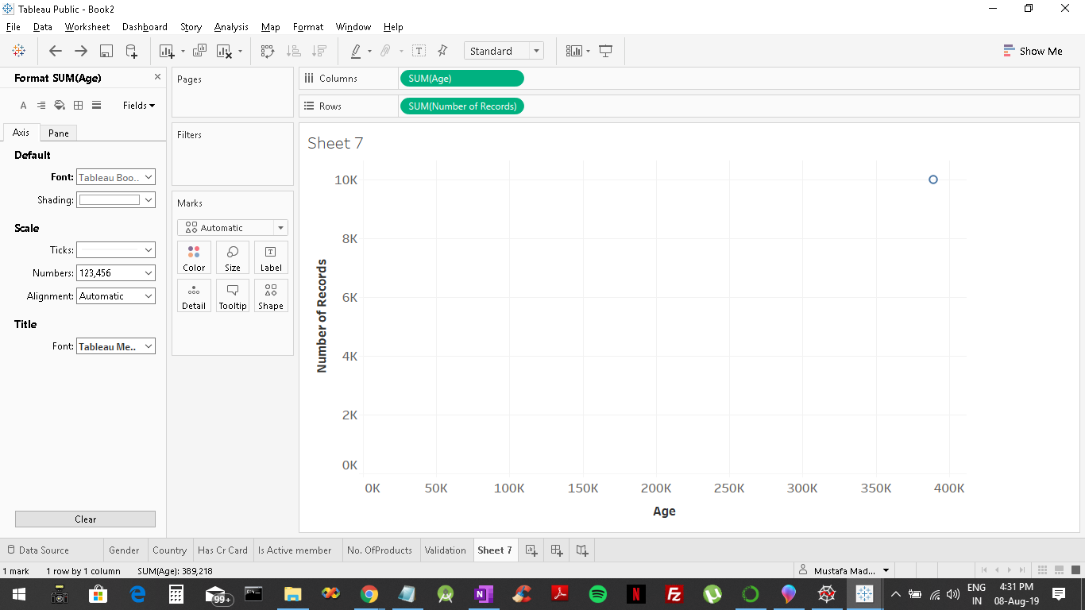

Turning age into a dimension from measurement gives us a graph.

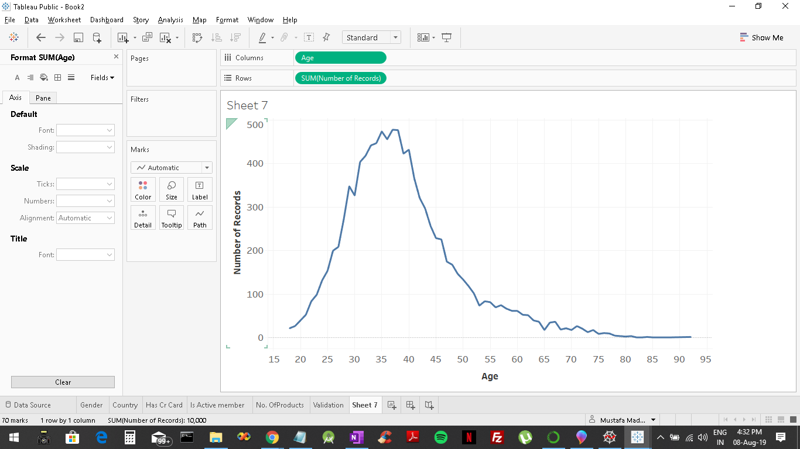

To create bins that is

What I want to do is I want to group people into bands.

So I want to group people into for instance 5 year bands anybody between 20 and 25 will go into one group of 25 to 30 will go to the next group and so on.

Right click on Age as a measure and create a bin-->Size of bins = 5 and a Age(bin) dimension will be created. And then drag Age(bin) in place of age in columns.

15-19,20-24 and so on bands or groups are created.

Drag sum of records + ctrl onto label and color to make it look more appealing.

Also to remove quick percentage as we did before right click on sum of records-->quick calculation-->percent of total.

Right skewed as the tail is going to the right.

To make it percentage - Right click on (T)number of records --> Quick Calculation --> Percent of Total

Test and age distribution

So here we can see which are the exact age groups who exited and stayed. So we can find a clear consensus of it.

The only problematic issue or anomaly we can find is that the age group of 75,85 and 90 in which no one left the bank so we will see further how to integrate the test and age distributions together to resolve that.

--------------------------------------

This below is an AB or a classification test just like we created before. And the other chart above (tail distribution) Tells us the distribution of age overall.

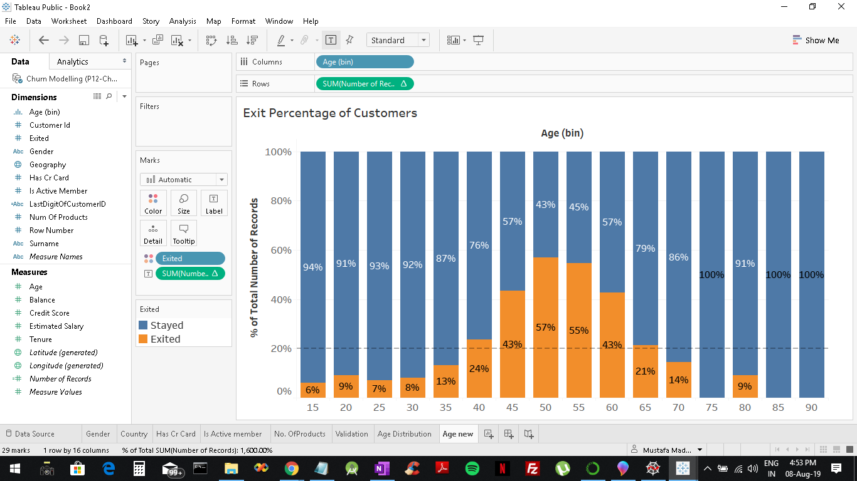

So to combine both of them together add no. of records to rows.

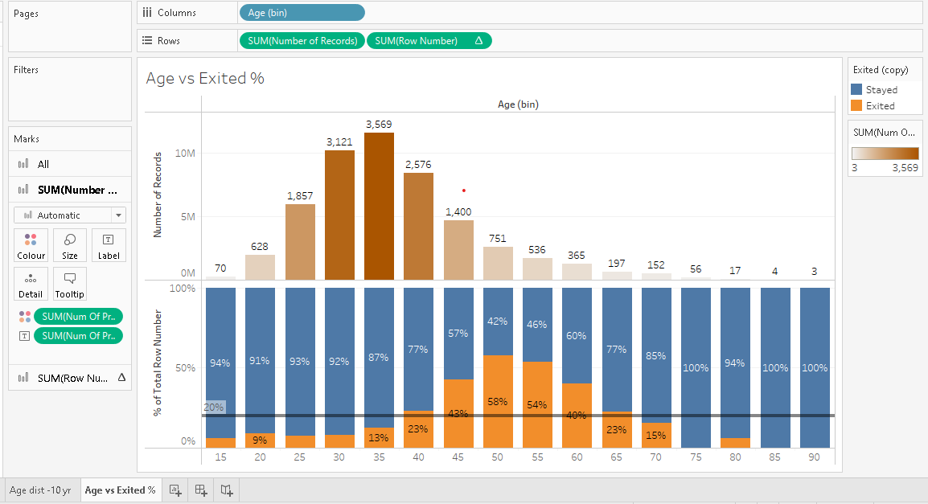

Well we can see that as we knew before our customers the most that are represented by these two age groups so between 30 and 40 or 45 years old.

And also in these two age group in these three age groups the probability of leaving is the lowest in the 30 to 35 it's high 35 but still below average.

And then at 40 45 it goes above average then the probability of living increases for these age groups. But the number of customers in these age groups reduces.

Conclusion –

Age has a significant impact on customers leaving the bank.

Gender also has a significant impact on customers leaving the bank.

But this is not the ideal way to do the A/B test

Validating Tableau Data Mining with a

Chi-Squared test

Go to <https://www.evanmiller.org/ab-testing/chi-squared.html>

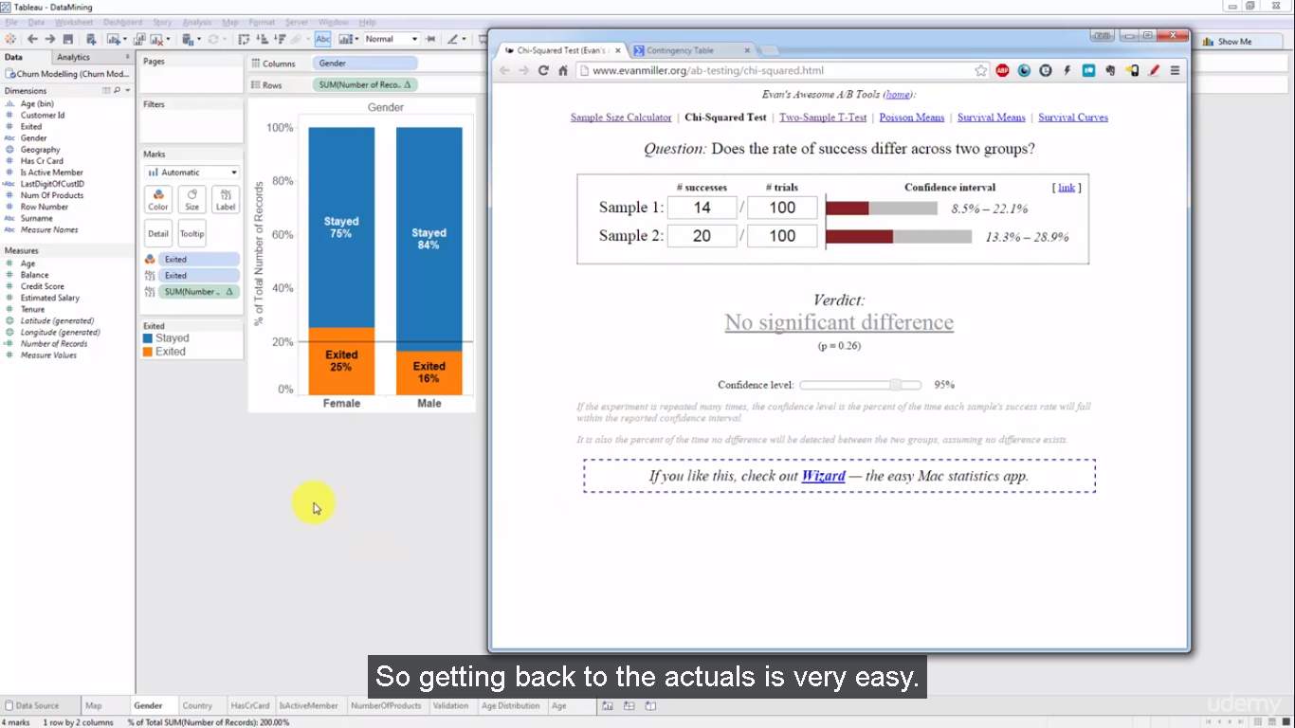

1 - Cannot use % with chi-squared

2 – Create Duplicate of Gender worksheet

3 – Duplicate Row number 🡪 to Number of Records 🡪 Drag inplace of Row number and also onto the Label Section

4 – To get the total Sum of Chi squared test

* Right click on axis – Add reference line – Per cell – Sum – Label (value)

Also for gender actuals add a new sum of records to rows and label

For this test you want the whole sum values and not the percentage and the grand total. So to show the grand totals we can follow this step:-

Hw – Add the Has cr card and Credit score and see the difference

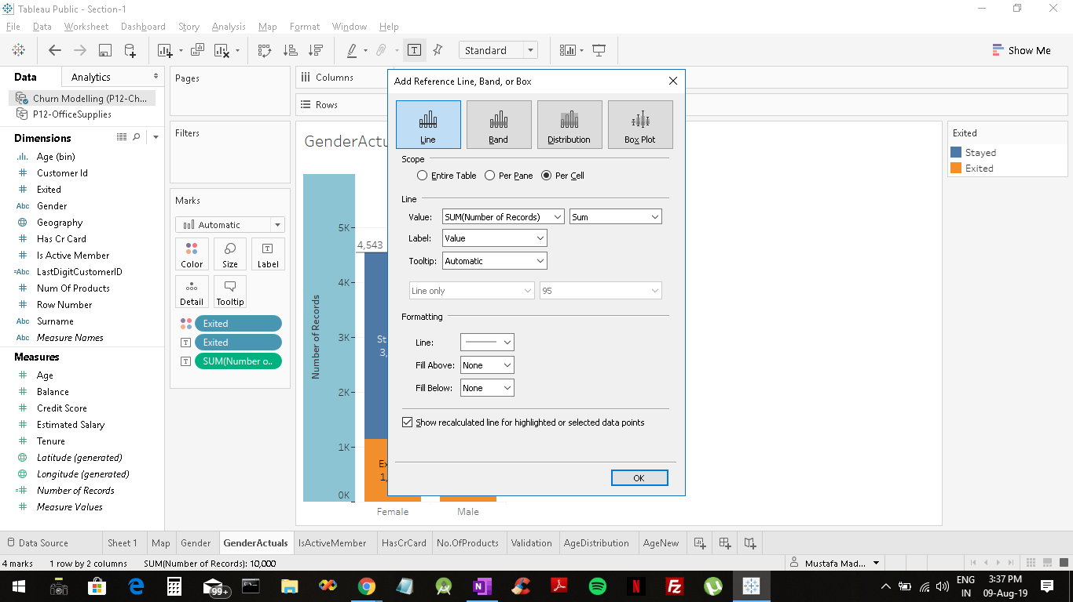

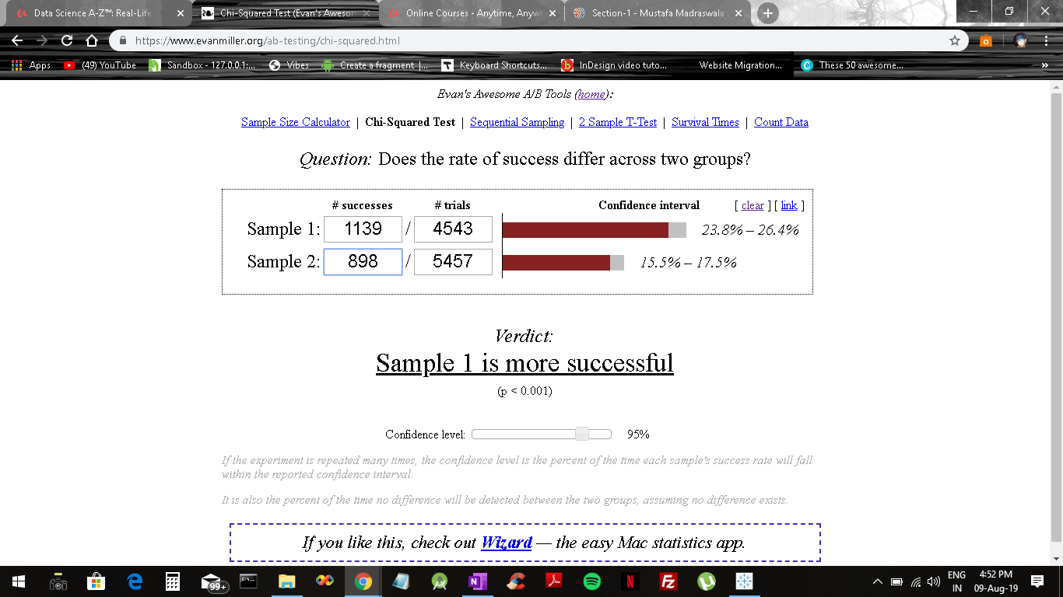

\\\\\\\\\\\\\\\\\\\\\\\\\\\\\\\\\\\\\\\\\\\\\\\\\\\\\\\\\\\\\\\\\\\\\\\\\\\\\\\\

<http://vassarstats.net/newcs.html>

 Chi-Squared test when there is more than 2 categories

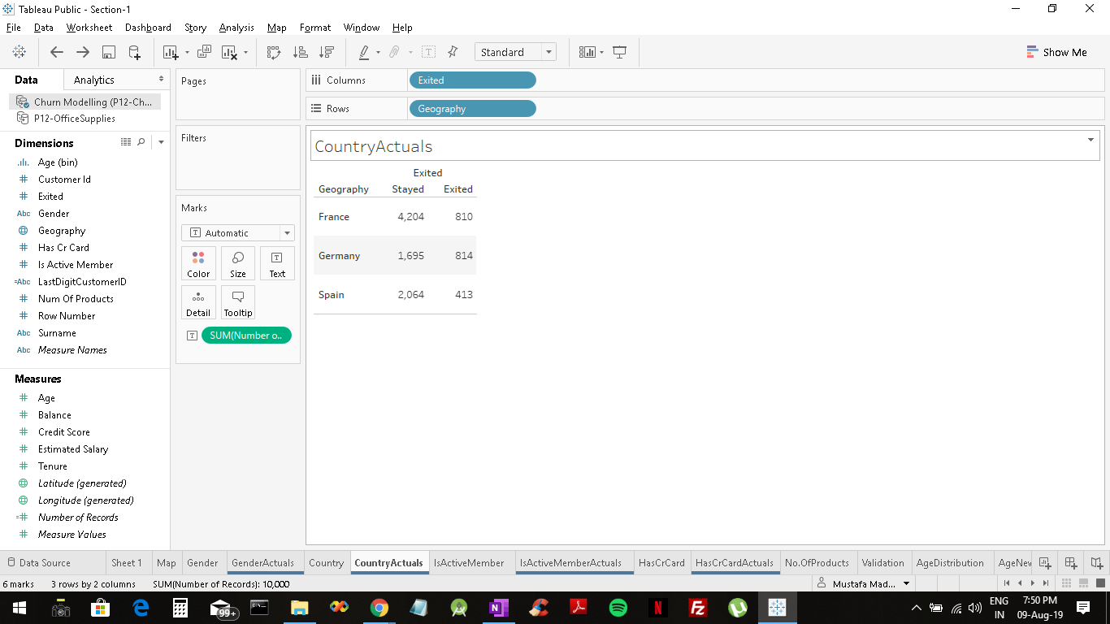

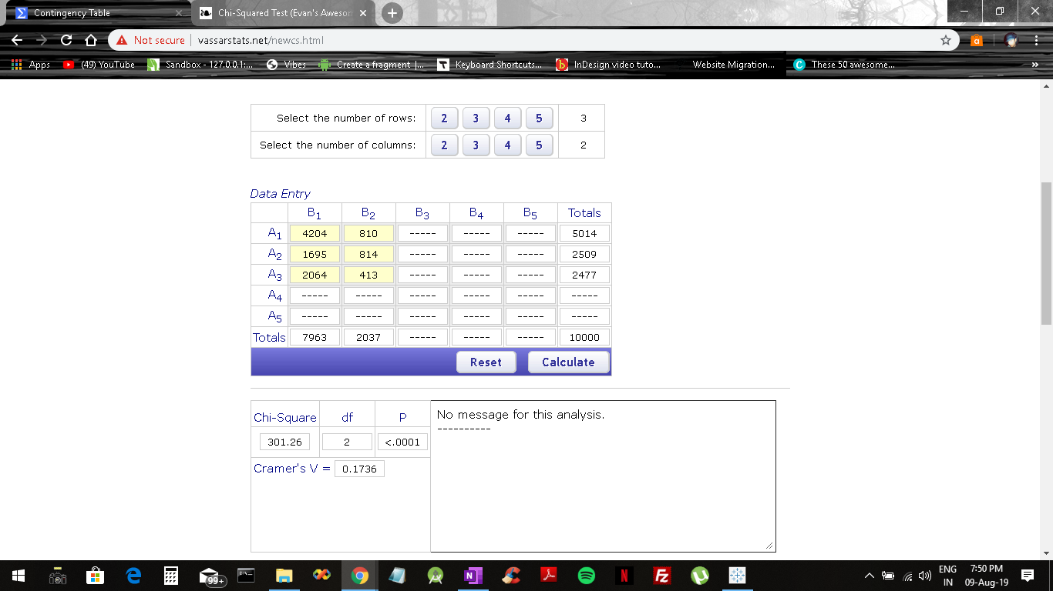

If we have multiple fields and values, we can also do the chi squared test by taking only a minimum of 2 fields with significant variation.

For example, between France and Germany.

And in case of age distribution where we have multiple fields we can take any two like 25 and 50 to check and validate the test.

**Visualizing Balance and Estimated Salary distribution – Column ( Balance(bin) )**

Creating a balance bin (size – 10,000)

Drag it in place of age bin and excluding the 0k to 10k field as a lot of people have 0 balance in their account and therefore our visualization is skewed.

Right click on column and Exclude

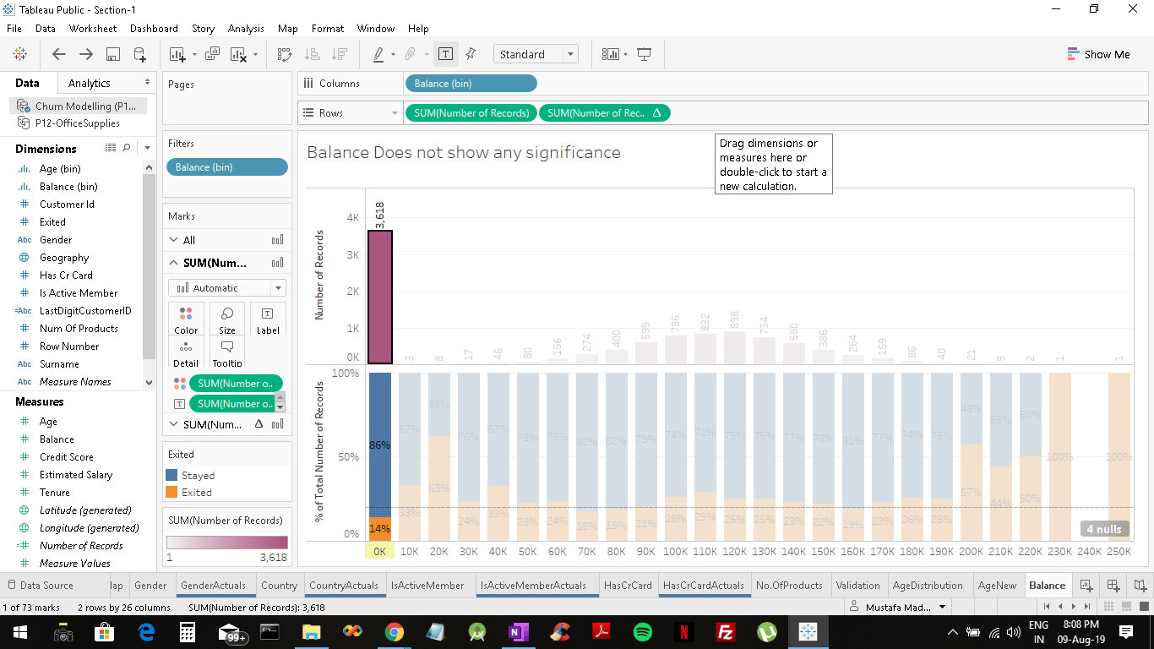

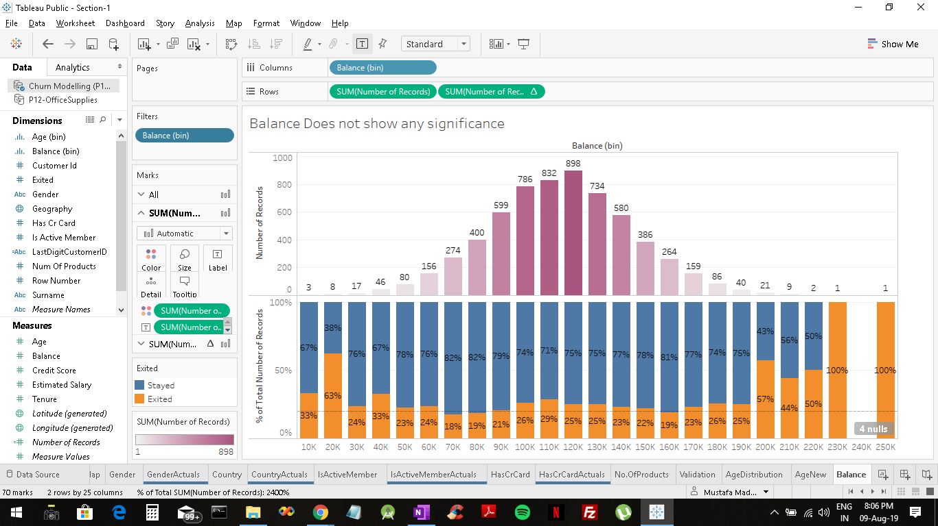

Create an estimated salary bin and drag and drop over balance(bin) and we will get a kind of uniform distribution as opposed to the balance(bin) graph. One would think that both of them should be similar as they are interdependent on one another but they are not and this is because the bank does not know the actual salaries of the individual customers and therefore they have only estimated them.

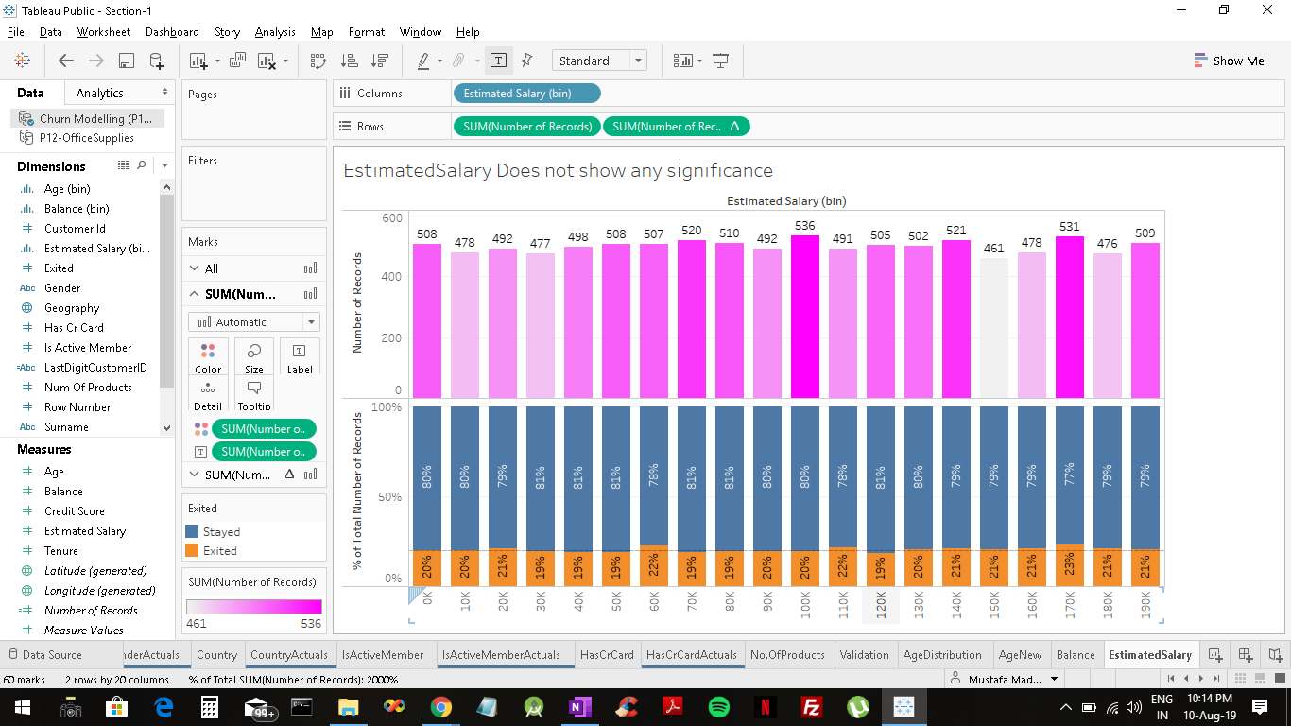

Well you got a hint here that estimated salary is actually has the word estimated meaning probably that the bank doesn't know what they're earning and they're estimating what these people are earning.

And you'd think that you'd use the balance to estimate what a person's earning rights somehow in the calculation would figure there. But doesn't look like it because there would be a trace of a normal distribution but there isn't here.

So one thing you can report from here is that this is going above and beyond your task. So here you know you've already said that no significant impact.

But then look at this you can say hey by the way it looks like the estimated salary calculation is completely wrong or out of whack because it's not giving adding any value just putting people uniformly across all bands and although that's not related to it that's how data mining works.

You will find that you will uncover very interesting insights about completely unrelated things to your analysis while you're doing analysis. And this is one of them so you can go back to the department that runs the system itself and say hey your calculations are dated or is an error or something is wrong with it.

Let's have a look at it.

Homework- Look at credit score and tenure.

///////////////////////////////////////////////////////////////////////

So in order to run us chi squared test this is an important part that you have to remember that you cannot use percentages you have to change percentages to the absolute figures so we're going to go back to our absolutes. Female 3404 Male 4599 stayed

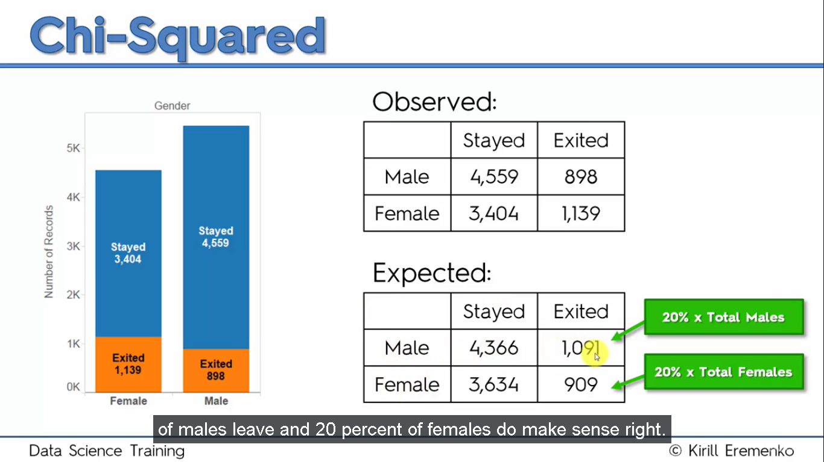

I’ll give you about 2000 and we know that there's a total in this whole table the total is 10000. So 2000 divided by 10000 gives you 20 percent 20 percent of people exit. Right.

So now this expected table what it represents is if there is no dependency so if leaving the company, the decision to leave the company is independent of gender then what we would expect is that 20 percent of males leave and 20 percent of females do make sense right.

So if you know that 20 percent of people overall leave the company from the sample size then it should be the same for males and females should be 20 percent here and should be 20 percent here. And that's exactly how you create this table so you calculate 20 percent of the total males you add up the males you get the 20 percent and then whatever's left.

And those are the ones that stayed and whatever went to females same thing you add up then you get 20 percent of that and whatever's left those customers decided to stay and that's what we expect to see.

So basically you take for eg. The female column.

3404+1139=4543 Now 4543 x20 divide by 100=90860=909-->females exited

Now 4543-909=3634-->females stayed

This will be the expected table for females. Do the same for males.

And so what the chi squared test will do for you it will tell you is the difference between this table and this table a random difference or is it a statistically significant difference.

So by default we say that the difference is not statistically significant. It's just a random coincidence so pretty much we're saying that this table is just like this table plus minus some little random error which we can discard.



Of gender.

--------------------------------------------------

For has credit card feature

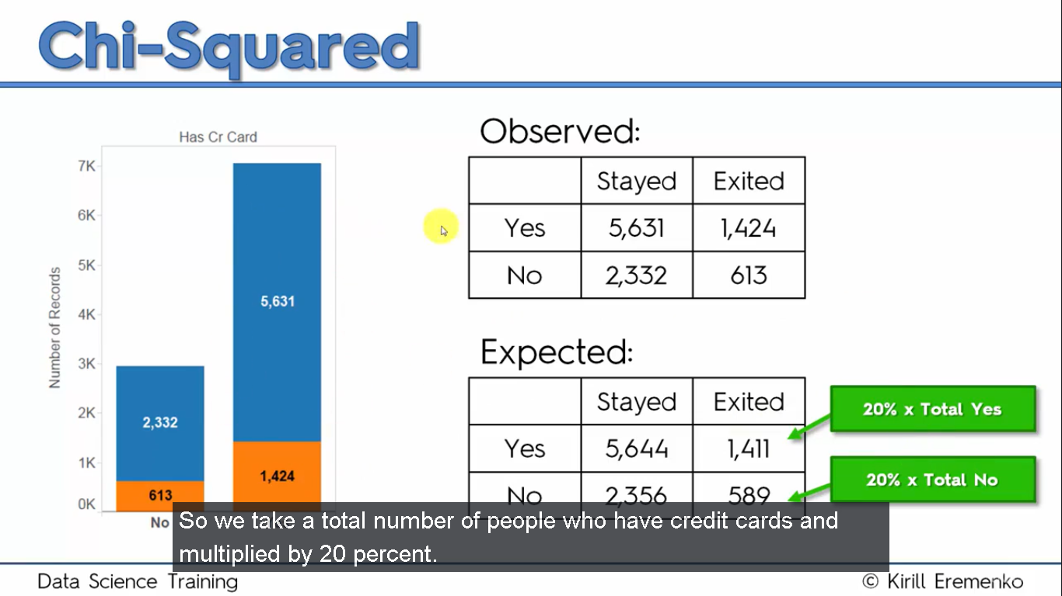

In excel

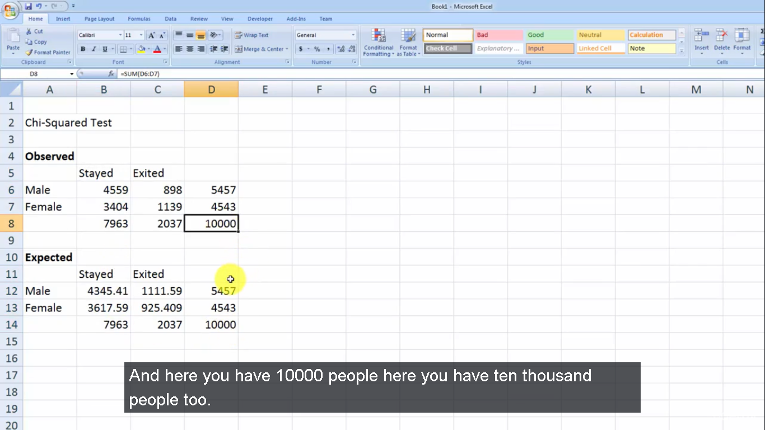

Alt plus plus

So P-value will basically tell you if what the chi squared test would result it's giving back to you

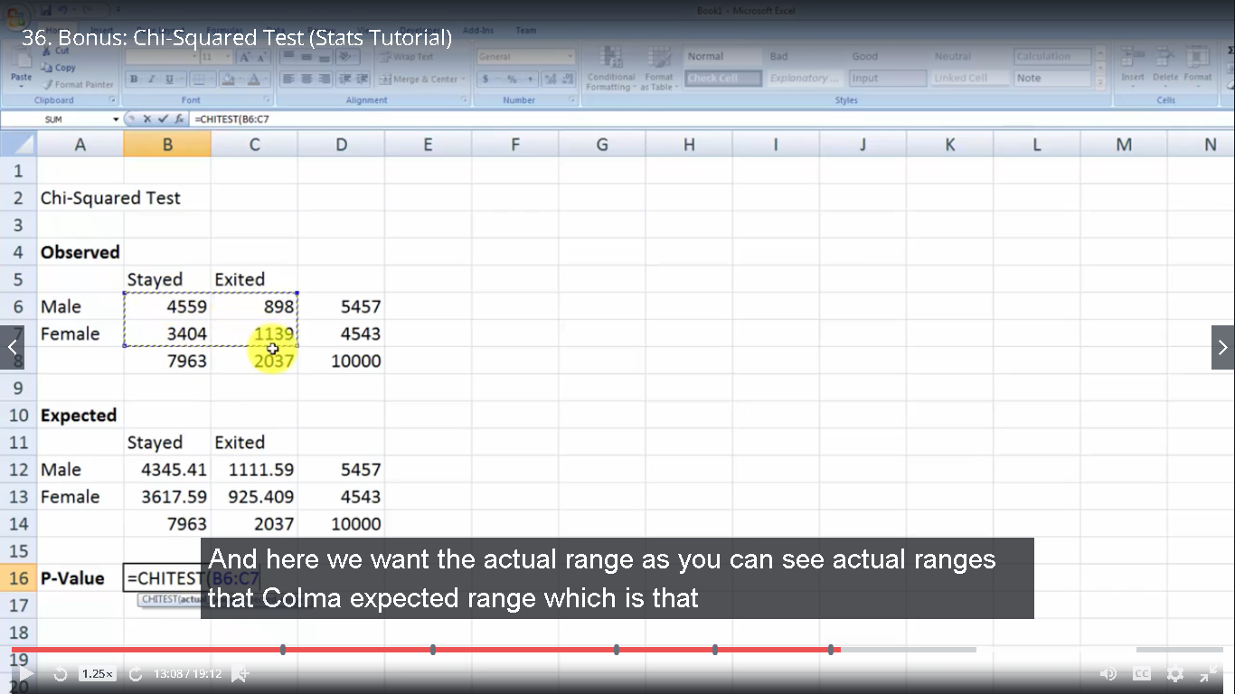

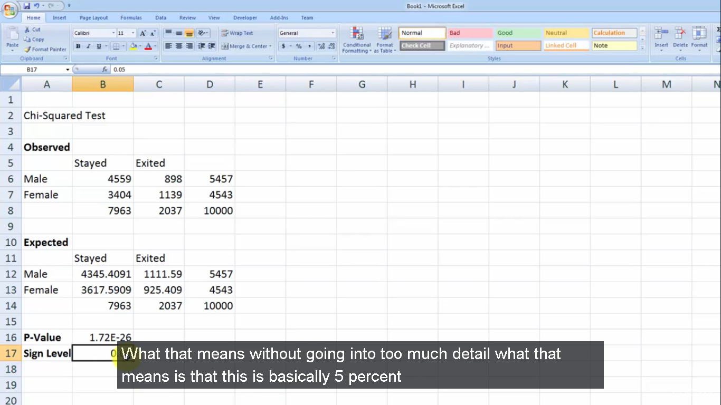

0.05

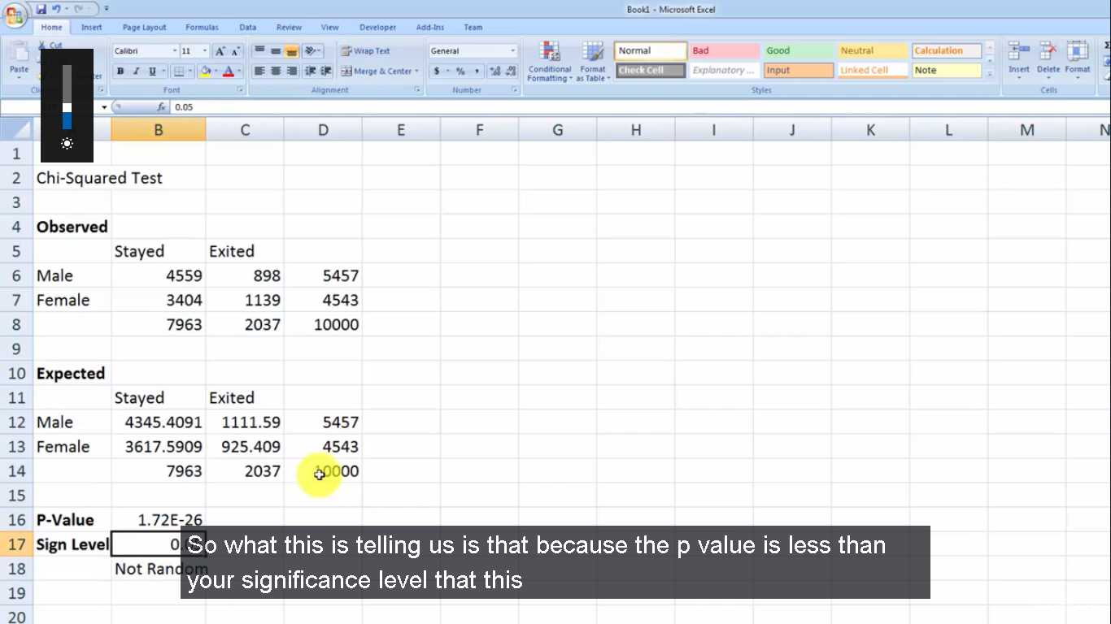

Is not a random result

So what this is telling us is that because the p value is less than your significance level that this is not a random result that what you're seeing is some sort of correlation that the results state are exited is actually dependent on your variable which is gender in this case.

If on the other hand the p value was greater than 0.05 then you would be able to say that the result is random meaning that your variable here is not dependent on age.

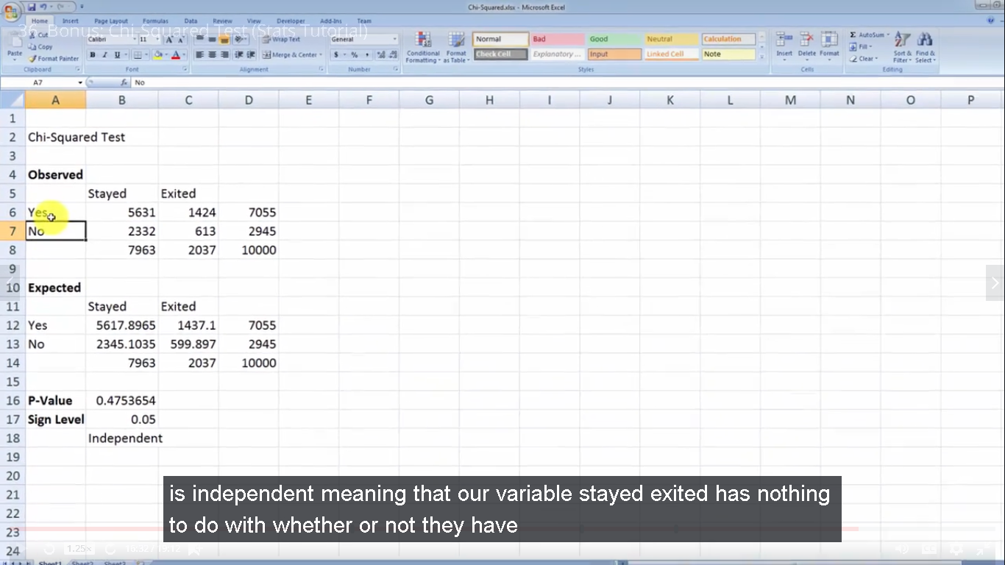

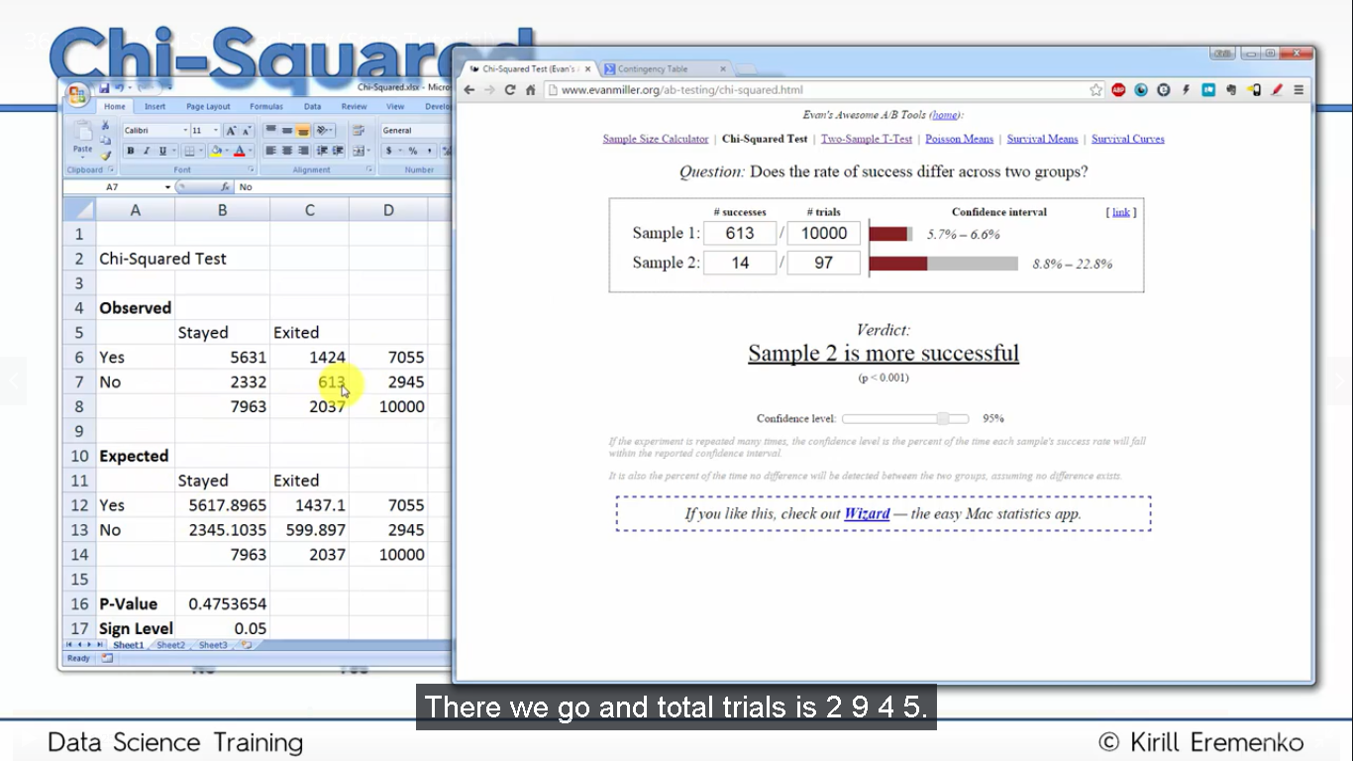

For has credit card

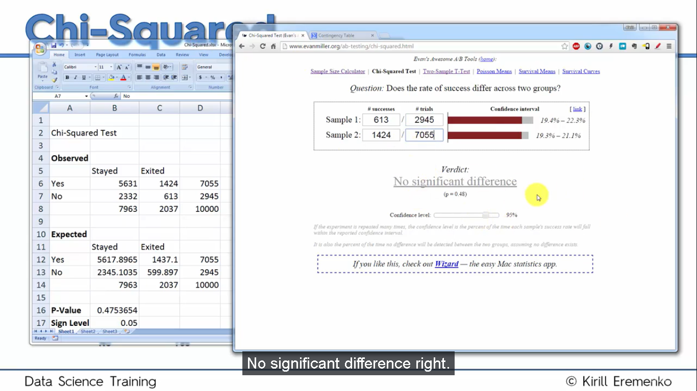

P=0.48

For gender

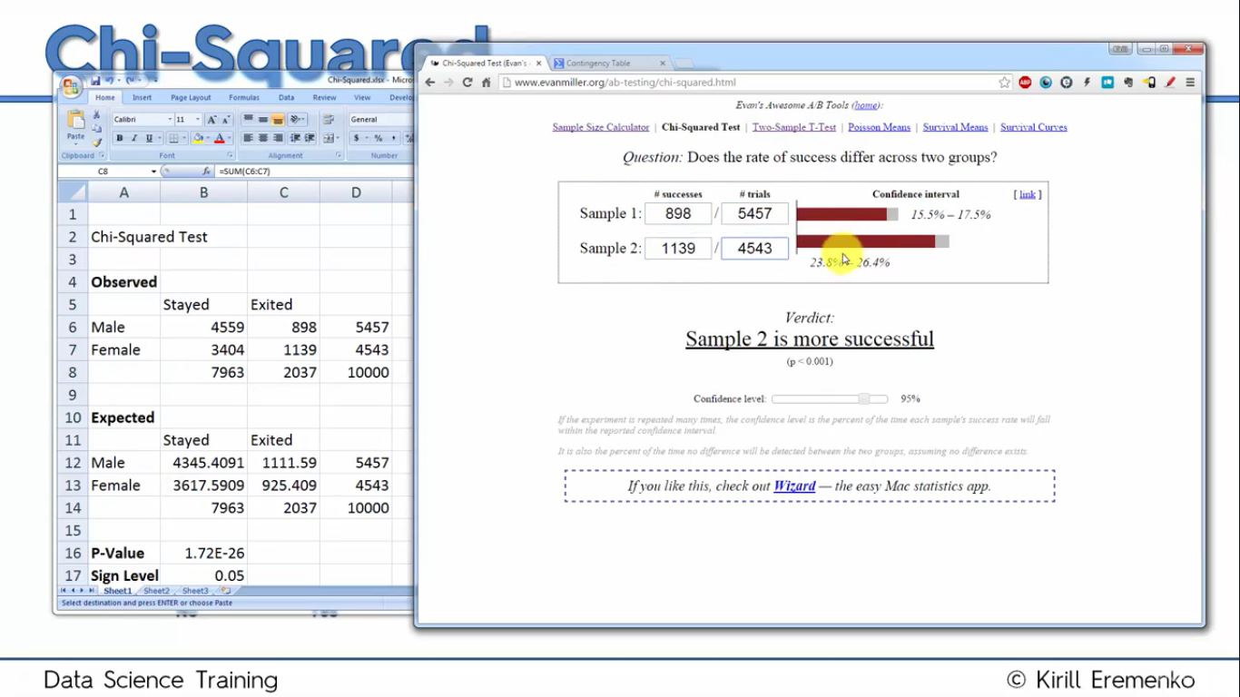

---------------------------------

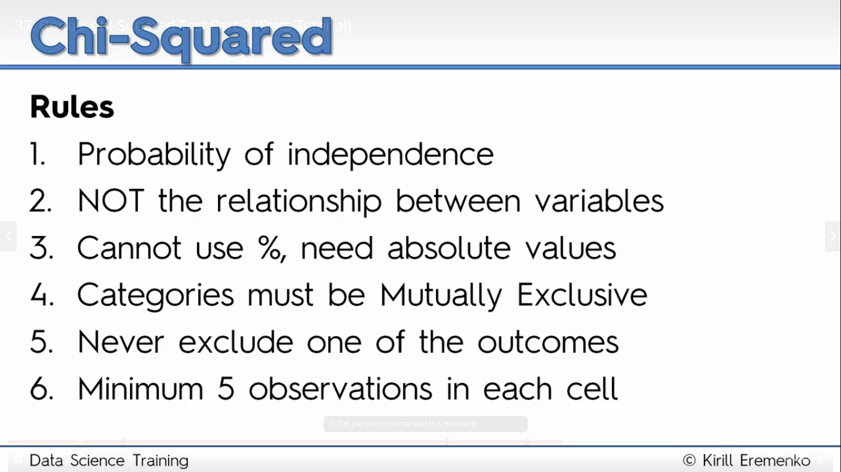

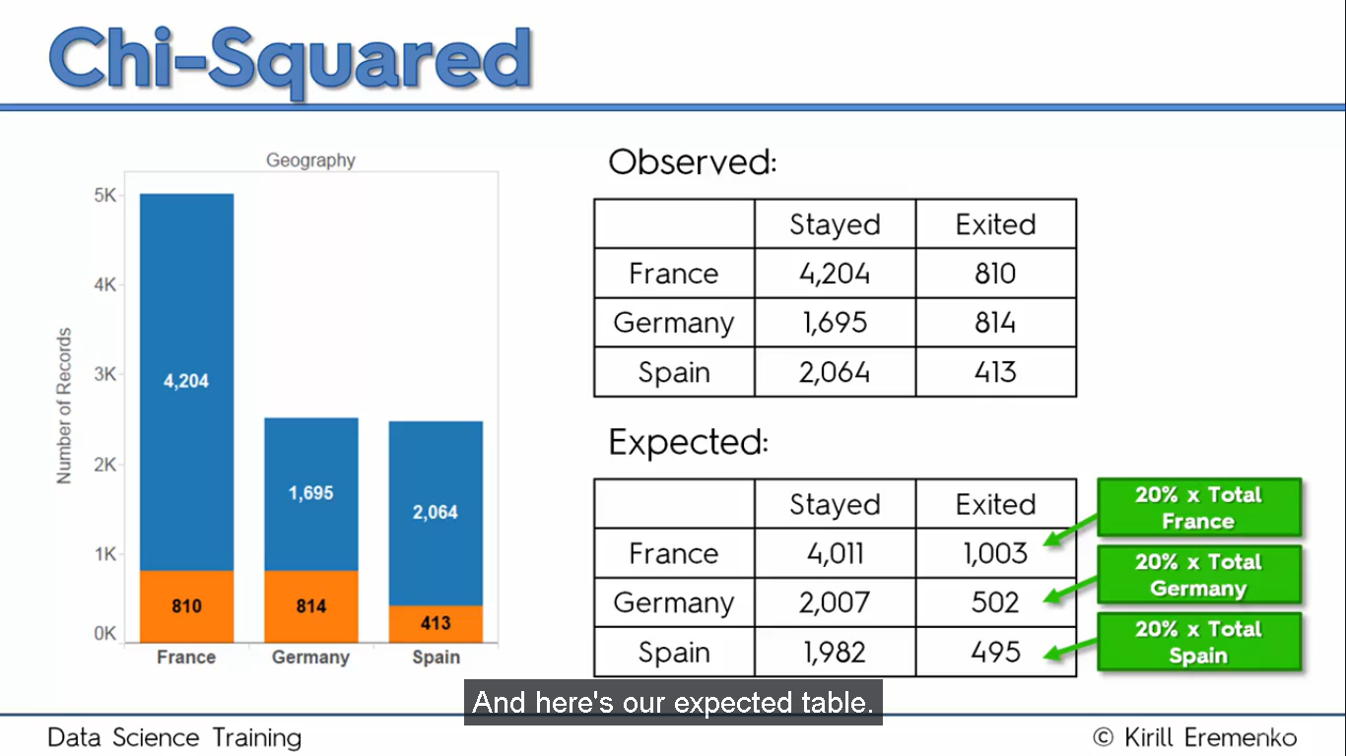

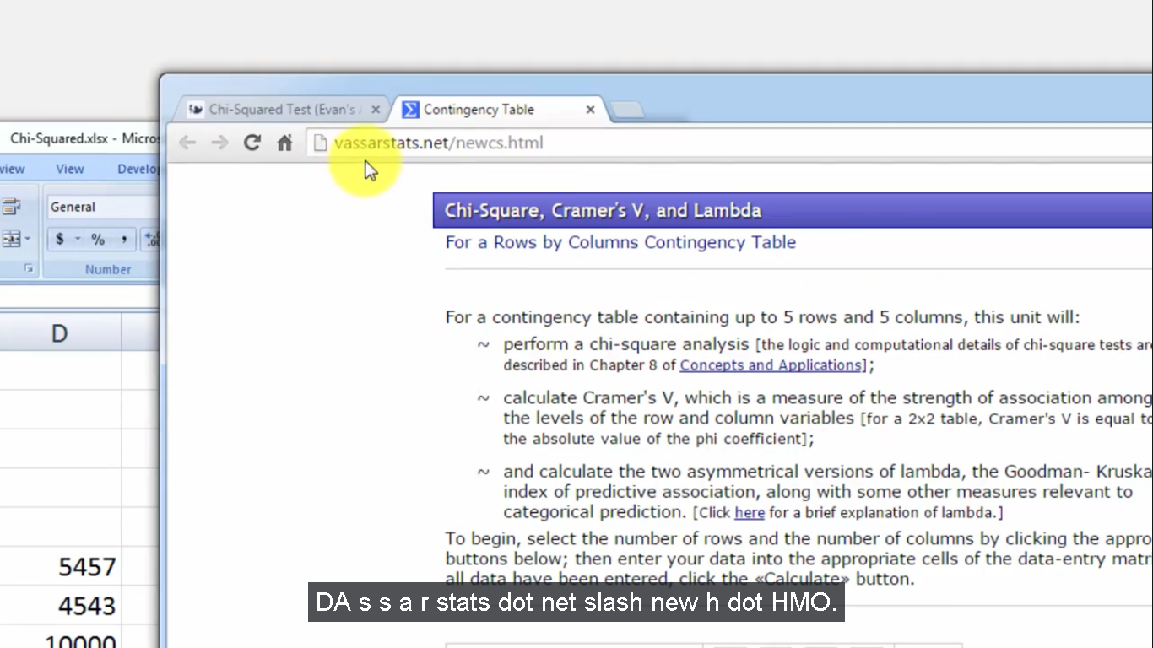

Website for chi squared test

